**Meeting minutes – Chenkster Prototype**

*24.02.2023 (Lau, Rena and Nikola – BA)*

1. Tracking KPI´s to be integrated. @Lau pls check based on your development what metrics you can generate/track out of the user usage. Enclose some thoughts on my side

* User clicks per page
* Nationality (e.g IP or within the Login)
* How many new users daily
* What is the dwell-time of a user
* Rating feedback of users on the proposed content within the Categories
* Downloads? (I guess as it´s a mobile app not really possible, but what can be done as alternative?

1. Add a country list without the need to swipe up due to unnecessary click and issue on iPhone. The upper part of the current screen need to be adjusted to not over-fill the view/page
2. For the moment, first page what a User will see when landing on the Mobile-App is straight a User Login. Important, among classic login possibilities (e.g. google, facebook) include the possibility to add a guest login (i.e. name, country, e-mail address)
3. Bookmark feature need to work, so that users can save proposed tips found within the category.
4. Current search Bar above the categories to be changed into a button, as it is more inclusive to avoid mixing category vs. search/chat. It should be a consistent button also in other screens
5. Preference/Filter button to be integrated. Subcategories to be deliverd by **NIKOLA**, see enclose the screenshot.

IMPORTANT subcategories can be “multiple choices”. Instead for exploration this doesn´t make sense, but for food and others it does. Another point is, that when we upload something into the Admin-Dashboard, we need to have the possibility to add the same thing to more categories (e.g. i´ve a food place it can go under “Eating Out” but also under “Hidden Gems”.

***Example of multiple choice on the preference filter:***

* ***Eating out 1:***
* ***Meat + fish + vegan***

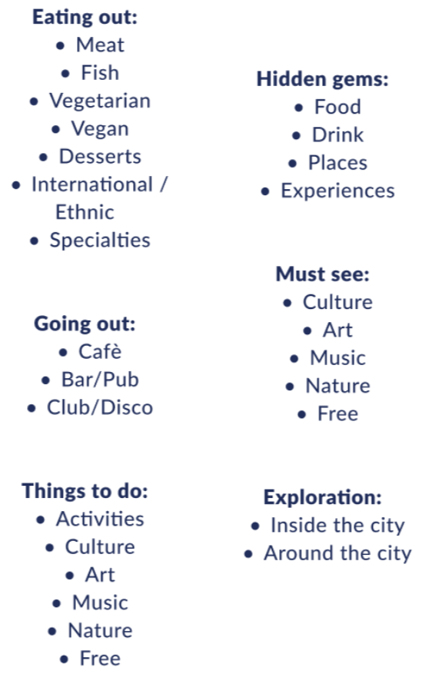

1. Shuffle function to be integrated, in dependency of the preference/filter first. Means, if I filter something to “Vegan” and then shuffle, only Vegan places should be shuffled. Instead of no preference/filter is set, then it shuffles all the DB.
2. Dashboard for Admins on Chenkster side as priority within the Figma screen. Best, to have the Figma like screen for 5 Admin Users/Roles available, so we can start to upload the content. Enclose also the excel with the content we have so far to be uploaded/integrated already.



1. I will setup regular 20 minutes calls. Please tell me what time you CANNOT do.